MATLAB & Simulink for Oil & Gas

The most popular applications in the upstream industry

**Predictive Maintenance**

MATLAB lets you develop predictive maintenance algorithms customized to the specific operational and architectural profile of your equipment. Use Predictive Maintenance Toolbox™ to design condition indicators and estimate the remaining useful life of your critical equipment like pumps and compressors.

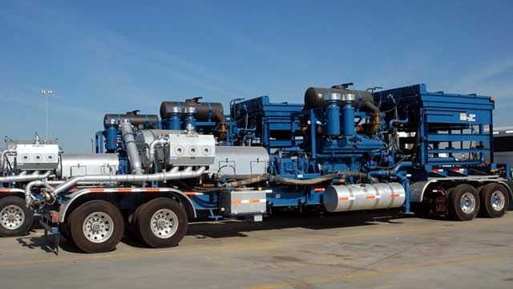

Ask us how **Baker Hughes** used MATLAB to implement a predictive maintenance platform for positive displacement pumps and saved more than $10 million.

**Geoscience, Image Processing, and Deep Learning**

Use MATLAB for geoscience applications like image processing in remote sensing, generation, and processing of digital elevation models. You can import a wide range of GIS and geospatial file formats, and use hundreds of inbuilt functions for signal processing, image analysis, and curve fitting.

Save time on tedious seismic interpretation activities like picking complex salt bodies by using deep learning for seismic feature detection and arrival picking.

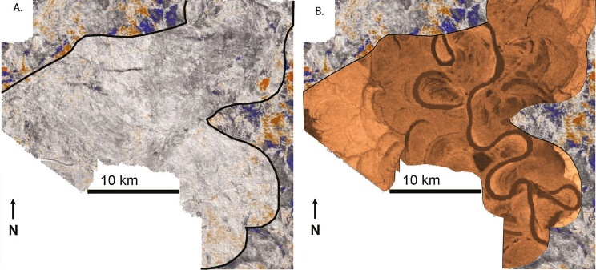

Ask us how **Shell** geologists deployed software for predicting subsurface geologic features with machine learning and trimmed months in making decisions.

**Real-Time Simulation and Hardware-in-the-loop**

Pair dynamic modeling with real-time testing in Simulink to better understand system behavior, develop plant designs, and implement control algorithms without hardware prototypes. Perform real-time HIL tests of systems for oil and gas production such as drilling, production, subsea construction, and process equipment with Simulink Real-Time™ and Speedgoat.

Ask us how **National Oilwell Varco** adopted Simulink Real-Time and Speedgoat to prototype their IIoT and edge analytics platform.

**Drilling Systems Modeling & Digital Twin**

# Use Simscape™ to model fluid systems, along with machines working with these fluids, for applications like managed pressure drilling. The Simscape product family offers multi-domain simulation so you can design logic and controls for multiple subsystems, such as mud pumps and AC motors, without deriving and implementing the system-level equations.

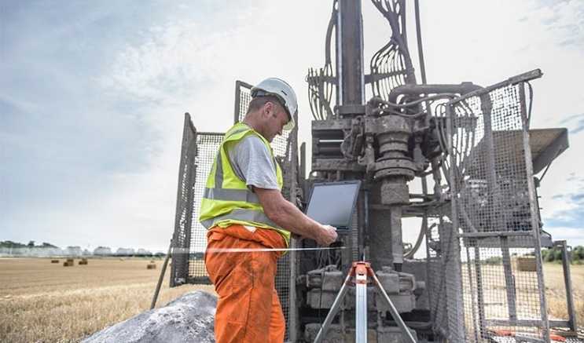

Ask us how **Transocean** monitored the performance of a subsea BOP pipe ram in Simscape using a digital twin based onadaptive physics-based models and edge analytics.

Left: Horizontal slice through seismic data cube & Right: Prediction of configuration of internal geology of reservoir target

**Data Analytics and Machine Learning**

# Combine machine learning, signal processing, and dynamic modeling methods in a single platform for applications like vibration analysis of drilling strings, studying oilfield decline rate and seismic and fracking analysis. Automate your seismic data processing steps such as working with SEGY files and processing shot record and travel-time field files. You can also interpret subsurface features using visualizations in MATLAB.

# Eliminate several data preprocessing and postprocessing steps for your Petrel project using the MATLAB interface for Petrel.

# Ask us how Halliburton made oil drilling safer using machine learning in MATLAB.

**Model-Based Design and Product Development**

Implement Model-Based Design with MATLAB and Simulink to reduce development time by 50% or more. Shift your resources and focus from code implementation and debugging low-level drivers to system design and testing.

Use App Designer and MATLAB Compiler™ to create standalone applications with custom UIs and share these with others – even if they don't know MATLAB.

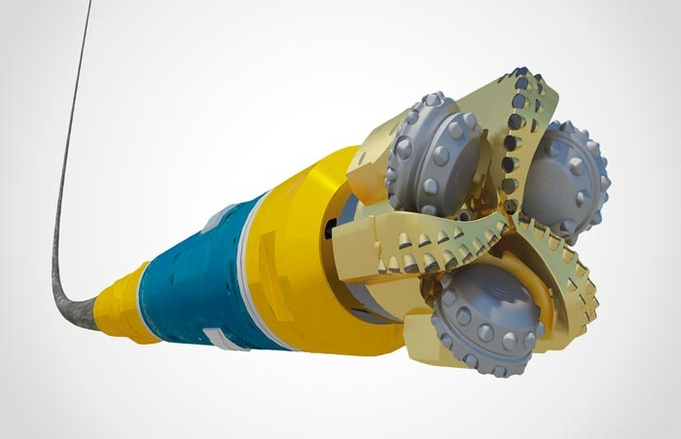

Ask us how **Baker Hughes** improved precision of drilling equipment and minimized expensive field tests using Model-Based Design.

**Energy Trading and Risk Management**

With MATLAB, you can simplify and automate your energy trading and risk management tasks like importing and visualizing energy data from multiple sources, building predictive models of energy time-series data, and running Monte-Carlo simulations for valuation and risk assessment.

You can also call MATLAB algorithms from other programs like Python®, and Excel®, and deploy these models on enterprise systems like Power BI, Cloudera®, and Hadoop®. The MATLAB API allows you to pick the best language or platform for each part of your workflow, and MATLAB serves as the glue between them all.

Ask us how **RWE**, one of Europe’s largest energy companies, deployed an automated system for Natural Gas and Power Trading by integrating MATLAB with SAP systems.

**Beyond the Desktop**

With the push of a button, you can generate C, C++, and HDL code to run on hardware. Create hardware-independent IEC 61131-3 Structured Text and Ladder diagrams, and deploy them on PLCs and PACs.

Use prebuilt big data analysis techniques and dedicated toolboxes to run your algorithms on multicore processors, clusters, and NVIDIA GPUs without learning new programming languages. Scale your programs to the cloud without recoding. Integrate MATLAB with PI systems without creating custom architectures.

Ask us how **Shell** and **Equinor** use MATLAB to build a production framework for processing multi-terabyte seismic data sets.

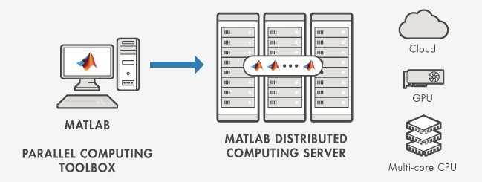

» mathworks.com/solutions/embedded-systems

# Learn More

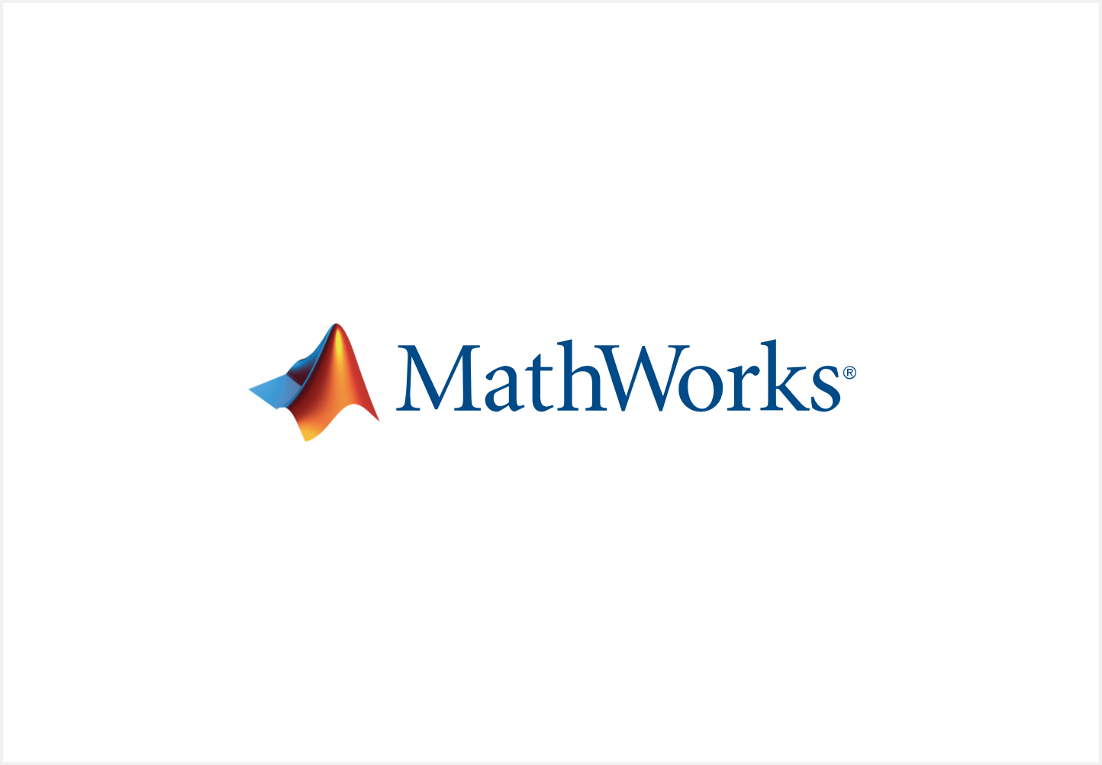

» mathworks.com/oil-and-gas